

Akshay Tiwari

Roll no 56

Experiment no 6:

Aim: Implementation of Singly Linked List

Objective : It is used ti implement stacks and queue which are linked needs throughout computer science .To prevent the Collision between the data in the Hash map.we use a singly Linked list

Theory

Singly linked lists contain nodes which have a data part as well as an

address part i.e. next, which points to the next node in sequence of

nodes. The operations we can perform on singly linked lists are

insertion, deletion and traversal.

Algorithm

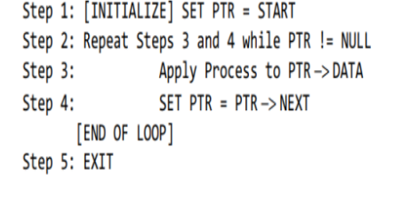

Code

#include <stdio.h>

#include <malloc.h>

#include <stdlib.h>

struct node {

int value;

struct node *next;

};

void insert();

void display();

void delete();

int count();

typedef struct node DATA_NODE;

DATA_NODE *head_node, *first_node, *temp_node = 0, *prev_node, next_node;

int data;

int main() {

int option = 0;

clrscr();

printf("Singly Linked List Example - All Operations\n");

while (option < 5) {

printf("\nOptions\n");

printf("1 : Insert into Linked List \n");

printf("2 : Delete from Linked List \n");

printf("3 : Display Linked List\n");

printf("4 : Count Linked List\n");

printf("Others : Exit()\n");

printf("Enter your option:");

scanf("%d", &option);

switch (option) {

case 1:

insert();

break;

case 2:

delete();

break;

case 3:

display();

break;

case 4:

count();

break;

default:

break;

}

}

return 0;

}

void insert() {

printf("\nEnter Element for Insert Linked List : \n");

scanf("%d", &data);

temp_node = (DATA_NODE *) malloc(sizeof (DATA_NODE));

temp_node->value = data;

if (first_node == 0) {

first_node = temp_node;

} else {

head_node->next = temp_node;

}

temp_node->next = 0;

head_node = temp_node;

fflush(stdin);

}

void delete() {

int countvalue, pos, i = 0;

countvalue = count();

temp_node = first_node;

printf("\nDisplay Linked List : \n");

printf("\nEnter Position for Delete Element : \n");

scanf("%d", &pos);

if (pos > 0 && pos <= countvalue) {

if (pos == 1) {

temp_node = temp_node -> next;

first_node = temp_node;

printf("\nDeleted Successfully \n\n");

} else {

while (temp_node != 0) {

if (i == (pos - 1)) {

prev_node->next = temp_node->next;

if(i == (countvalue - 1))

{

head_node = prev_node;

}

printf("\nDeleted Successfully \n\n");

break;

} else {

i++;

prev_node = temp_node;

temp_node = temp_node -> next;

}

}

}

} else

printf("\nInvalid Position \n\n");

}

void display() {

int count = 0;

temp_node = first_node;

printf("\nDisplay Linked List : \n");

while (temp_node != 0) {

printf("# %d # ", temp_node->value);

count++;

temp_node = temp_node -> next;

}

printf("\nNo Of Items In Linked List : %d\n", count);

}

int count() {

int count = 0;

temp_node = first_node;

while (temp_node != 0) {

count++;

temp_node = temp_node -> next;

}

printf("\nNo Of Items In Linked List : %d\n", count);

getch();

return count;

}

### The syntax for creating a node

struct Node

{

int Data;

Struct Node *next;

};

## Insertion of a node

void insertStart (struct Node **head, int data)

{

struct Node *newNode = (struct Node *) malloc (sizeof (struct Node));

newNode - >

data = data;

newNode - >

next = *head;

//changing the new head to this freshly entered node

*head = newNode;

}

## Deletion of a node

void deleteStart(struct Node **head)

{

struct Node *temp = *head;

// if there are no nodes in Linked List can't delete

if (*head == NULL)

{

printf ("Linked List Empty, nothing to delete");

return;

}

// move head to next node

*head = (*head)->next;

free (temp);

}

## Traversal in a Singly Linked List

void display(struct Node* node)

{

printf("Linked List: ");

// as linked list will end when Node is Null

while(node!=NULL){

printf("%d ",node->data);

node = node->next;

}

printf("\n");

}

Out put

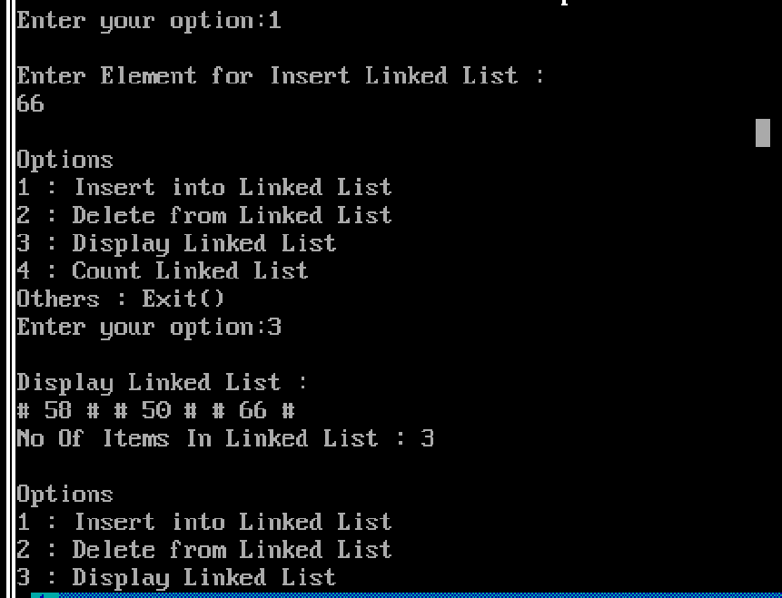

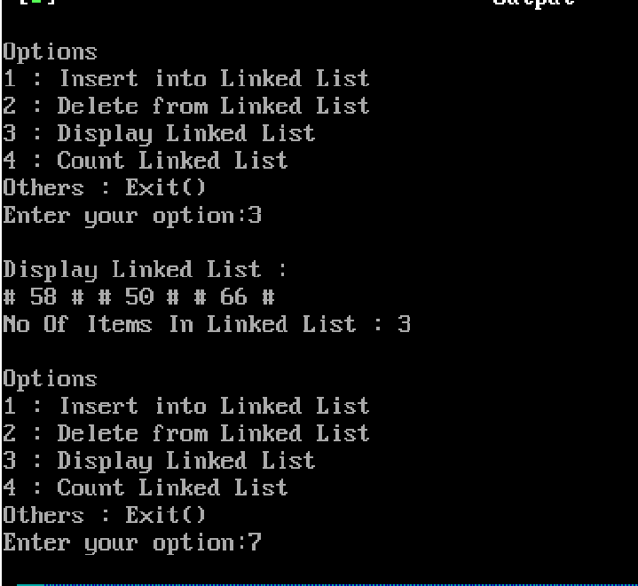

Conclusion :